

**CHAPTER 1**

**INTRODUCTION**

 Amazon Web Services (AWS) is a secure cloud services platform, offering compute power, database storage, content delivery and other functionality to help businesses scale and grow.

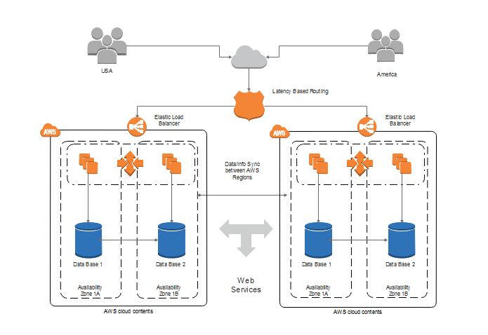

In this project we are trying to securely delivering the desktop application to a web browser and deploying it in a cloud using amazon web services of AppStream 2.0 .we have a created a desktop application of customer relationship management with college management information

* 1. **PROBLEM DEFINITION**

a desktop application is a computer program that runs locally on a computer device, such as desktop or laptop computer, in contrast to a web application, which is delivered to a local device over the Internet from a remote server.

* The desktop applications can be stored and it can be shared to the browser. This applications will be saved in the server. The assurance of secure usage of applications cannot be given in this system.
* The data’s will be more securely shared to browser without any server problems or any other storing problems.
* The shared applications, data’s can be secured in VPC services and will be available 24/7.
* Provision an Amazon virtual private cloud (Amazon VPC) to provide an isolated virtual network infrastructure within the AWS Cloud. This AppStream 2.0 resources will use this environment.

**1.2 OBJECTIVE OF THE PROJECT**

The objective of this project is to deploy and stream desktop applications by using Amazon AppStream 2.0, a fully managed, secure application streaming service that runs in the AWS Cloud.

The main requirements that needed to start our project is as follows:

• **An AWS account:** You need an AWS account to use AppStream 2.0 and other AWS services. For information about how to sign up for and activate an AWS account, see Appendix A.

• **A current email address:** During the user configuration process for your AppStream 2.0 environment, AWS sends you two emails. You must use these emails to complete the process. 3

• **Skill level:** You do not need prior experience with AWS to complete these exercises. A basic understanding of desktop computing is helpful but not required.

In this project, our main objectives are as follows:

* To ensure easier and secure delivering data.
* To minimize the time consumption.
* To has 24*7 access to the data.
* scalability

**1.3 SIGNIFICANCE OF THE PROJECT**

* It is important to import desktop application to build image builder.
* Helps to stream the services.
* Easy and secure application.

**1.4 OUTLINE OF THE PROJECT**

* We can control the permissions who can access them. The administrative tasks can be performed in the AppStream console
* Create network resources- create an Amazon virtual private cloud (VPC) and other network resources required for your AppStream 2.0 environment.
* Create an AppStream 2.0 image builder and create a user pool to manage users who access your streaming applications.
* Add a payment method if not you can use free aws account with free trial
* Remember to delete the resources that you created in these exercises to avoid further charges to your account.

**CHAPTER 2**

**LITERATURE REVIEW**

**Introduction:**

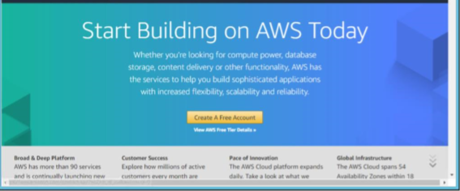

* In this project we come to know how to configure, manage, and stream desktop applications to your users with Amazon AppStream 2.0.
* AppStream 2.0 is a fully managed, secure application streaming service that allows you to stream desktop applications from AWS to an HTML 5 compatible web browser, without rewriting them.
* Users can access desktop applications from any computer, including Chrome books, Macs, and PCs.
* Installation and configuration of applications on AppStream and stream the applications to the users. The applications are accessed through an HTML 5 browser, and we can control the permissions who can access them.
* Perform administrative tasks using the AppStream console. We can install applications using the image builder, optimize your applications with the Image Assistant, provision a fleet for your applications, and provision a stack to stream your applications to users.
* Provision to an Amazon Virtual Private Cloud (VPC) using a provided AWS CloudFormation template. The VPC will host the AppStream 2.0 resources within the isolated virtual network infrastructure.

**Modules Used In this project**

* Module 1: Creating Network Resources and AppStream image builder
* Module 2: Connect to the image builder and install the app
* Module 3: create AppStream Image.
* Module 4: Provision a fleet and Appstream Stack and Manage Users.
* Module 5: Testing the User Experience and Streaming.

**STEPS FOLLOWED:**

* Step 1. Sign in to the AWS Management Console and select an AWS Region
* Step 2: Create network resources
* Step 3: Create an AppStream 2.0 image builder
* Step 4: Connect to the image builder and install applications
* Step 5: Use Image Assistant to create an AppStream 2.0 image
* Step 6: Provision a fleet
* Step 7: Create an AppStream 2.0 stack and a streaming URL
* Step 8: Manage user access with an AppStream 2.0 user pool
* Step 9: Test the end user authentication and application streaming experience
* Step 10: Take the next step with AppStream 2.0

**Appstream 2.0**

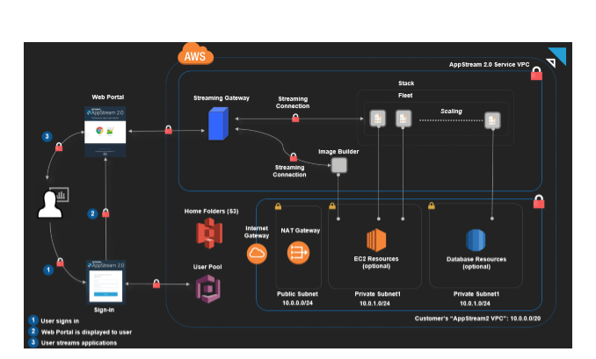

**Algorithms can be used:**

* KMS – Key Management System
* AES – Advanced Encryption System

**Software requirements:**

* Android Studio
* Amazon Web services
* Appstream 2.0
* java
* Spreadsheet